Post-Migration Review

Course Designator:
My Ultra Sandbox Shell ID: __________________________

Course Review
Action To Take
Module Review: Content Presentation | Course Navigation
Review each module for the following:
☐ Review for images or graphics that did not transfer over fully or accurately. Do they need to be re-created in Ultra or formatting cleaned up?
☐ Does course make use of bulleted lists? Formatting of bulleted lists may become compromised during the transfer to Ultra. Review and adjust as needed. Bulleted lists are found in the Content Editor by clicking on the Paragraph icon: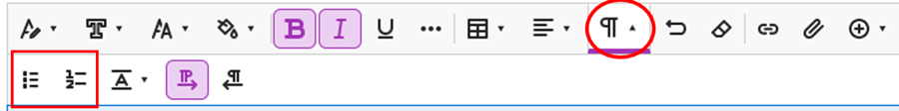
☐ Does course contain tables or charts? Formatting may become compromised on tables and charts during the migration process. Review and adjust as needed, keeping in mind, rows and columns in Ultra are not resizable. If a header row or column is used within a table, be sure to check the “Header Row” and/or "Header Column" box on the table for screen-reader accessibility:
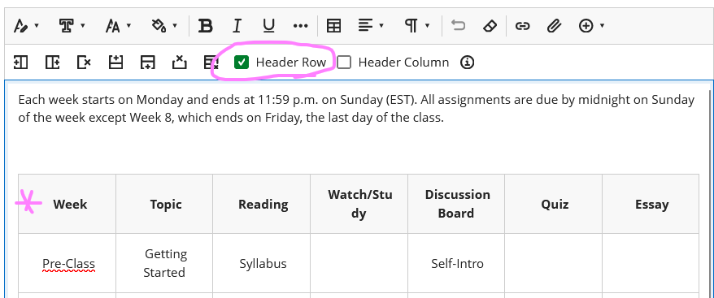

☐ Review verbiage throughout the Ultra course. Does messaging refer to the course menu or menu buttons previously found in Original or other terminology no longer used in Ultra (e.g. My Grades, Discussion Board)? Is verbiage in sync with how content is presented or how users navigate the Ultra course shell? Adjust verbiage as needed to reflect current course structure and setup.
☐ Ensure titles to items are short & concise. Omit extra words.
☐ Are course links needed to direct users to other content items in the course? NOTE: Course links are not compatible with the Forced Sequence feature.
☐ Ensure content items are in the correct sequential order within a module for folder (e.g. in the order you want students to access and complete them). If helpful, use Student Preview mode to view/access content as a student and make adjustments as needed.
☐ Determine if any content items need Forced Sequence (for modules only) or Release Conditions set.
☐ Review the course schedule (found in the Course Orientation & Overview module) to ensure it accurately reflects content presented in modules and vice versa.
☐ If the Library link is unique for your course, update the Library link in your Ultra shell by editing the link and replacing the URL with the correct one.
Announcements & Discussions
☐ Review Announcements: do they need to be scheduled to release on a date/time in the future? Should they be posted, placed into ‘draft’ mode for later posting? Is there an announcement welcoming students to class and guides them on how to get started? If not, create one.
☐ If used, review Discussions to ensure proper setup. Ensure Discussion prompts were not placed in the title area of the forum. If they were, move the prompt to the description. Ensure point values and due dates have been configured if the forum is a graded activity.
☐ Are forums in the order desired? If not, re-arrange using the drag and drop feature.
☐ Do any of the forums require students to make their initial post before being able to see their classmate’s posts? If so, ensure the Post First setting is checked.
☐ If desired, add a link to the discussion forum within its respective module by clicking the “Display on Course Content page” box. Note: when checked, the Discussion link is placed at the end of the content listing on the Content page and needs to be dragged and dropped into its respective module.
☐ If small group discussions are being held in the course, ensure these have been properly set up (see below Groups & Group Activities for group set up).
Groups & Group Activities
Skip this section if Groups/Group Assignments are not used in the course.
☐ Confirm groups are properly set up in the course (Groups Tab > Manage Groups) and attached to their respective group activity.
☐ Ensure details of the group activity are communicated to students in the course:
  - If self-enrolled groups, is the deadline to enroll in a group shared?
  - What is the maximum number of members per group?
  - Can students see who is currently enrolled in a group?
  - Is there a description associated with each group or group set?

Graded Activity Review
☐ Ensure assignment & assessment instructions are clear and concise, conveying important details of expectations and requirements, or what to expect on a test.
☐ If a rubric has been built in Bb for the graded activity, ensure it is attached to the assessment and migrated over accurately. If a rubric doesn't currently exist, consider adding an AI-generated rubric to the course.
☐ If applicable, consider use of SafeAssign, Blackboard’s plagiarism detector.
☐ Configure Due Dates for graded activities.
☐ Is this a 500-level course? If so, it should contain a graded activity for graduate-level students only to earn grad-level credit. If so, consider a consultation with CIS to discuss setup within the Ultra course shell. See 500-Level Course Assignment Set Up for Graduate Students
☐ Is there a semester-long project students will work on throughout the course? If so, are course links to the assignment overview needed within other modules?
☐ Carefully review configuration settings for all graded activities to ensure set as desired. Pay particular attention to test settings: presentation of questions including randomization of questions and/or answers, time limits, number of attempts, and assessment feedback. If Respondus Lockdown Browser and/or Monitor is being used for a test, ensure this has been activated.
NOTE: If using Lockdown Browser, how students access an LDB test has changed in Ultra. Copy in updated/accurate instructions on LDB from the Bb-Repository.
NOTE: Tests copy into Ultra without feedback settings set. You will need to review test configuration settings to set up feedback options and grant permissions. See Assessment Results & Feedback.
☐ Review test questions to ensure content/images/tables/graphics accurately display. Adjust formatting as needed.
☐ Would test questions benefit from being organized into groups or sections using Page Breaks?
☐ Do tests contain essay questions that use of SafeAssign should be considered for? NOTE: the ability to add SafeAssign on essay test questions is a new feature of Ultra.
☐ Do assessments require students to submit proof of their work for partial credit? NOTE: Assessments in Ultra have an Allow Students to Add Content at the End of Assessment feature that when checked, allows students to submit proof of their work for partial credit.
Gradebook Setup
☐ Set up the Overall Grade column.
☐ Review the Gradebook for accuracy and adjustment. Is the Gradebook in sync with the Syllabus and total points communicated within the course?
☐ Review Grading Schema: From the Gradebook settings (gear icon) > Manage Schemas. Does the Letter Grading Schema reflect your course (e.g. 94-100% = A). If not, adjust this schema as needed.
☐ Set Performance Thresholds: From the Gradebook settings (gear icon) > Student Performance Section: set the desired alerts for # of days inactive in the course, # of missed due dates, and overall grade percentage.
☐ Organize the Gradebook: Review the order of items listed in the Gradebook and rearrange these items in the order desired using the drag and drop feature.
☐ Are there any unique grading needs (e.g. dropping lowest score, use of weighted grades, etc.)? If so, consider a consultation with CIS to discuss setup within the Ultra course shell.
☐ Are there any Pass/Fail or Complete/Incomplete activities in the course or desired to be setup in the Ultra course?
☐ Do you wish to take Attendance in your course?
Course Tools | Virtual Meetings
☐ Does the course use 3rd party software or tools (e.g. Connect, MindTap, MyLab, FeedbackFruits, etc)? If so, consider a consultation with CIS to discuss setup within the Ultra course shell.
☐ Does the course hold virtual class meetings? If so, consider use of Microsoft Teams which provides an enhanced integration with Bb Ultra.
Course Resources
☐ Have resources that support student academic success been added to the course? If needed, self-help resources can be copied into your course from the Bb-Repository-Ultra course (search for this course from Copy Content, then navigate to the Self-Help Resources module to select the resources you would like to copy into your course.)
Course Image(s)
☐ If desired, add images to modules that align with the subject matter.
☐ Add a Course Image to your course to personalize it.
New Feature Considerations
☐ Consider use of these new features in your Ultra course.
Final Review & Copy
☐ Enter into Student Preview mode and navigate through the course as a student, making adjustments as needed to content visibility, navigation, settings, etc. Adjust content visibility using Batch Edit to ensure students can see/access content.
☐ Once course is finalized and your Ultra teaching shell is available copy content from your Ultra sandbox shell to your Teaching shell.

